MT Hope Shopping Plaza
1659-1691 Mt Hope Avenue, Rochester, NY 14620
(770) 578-1067

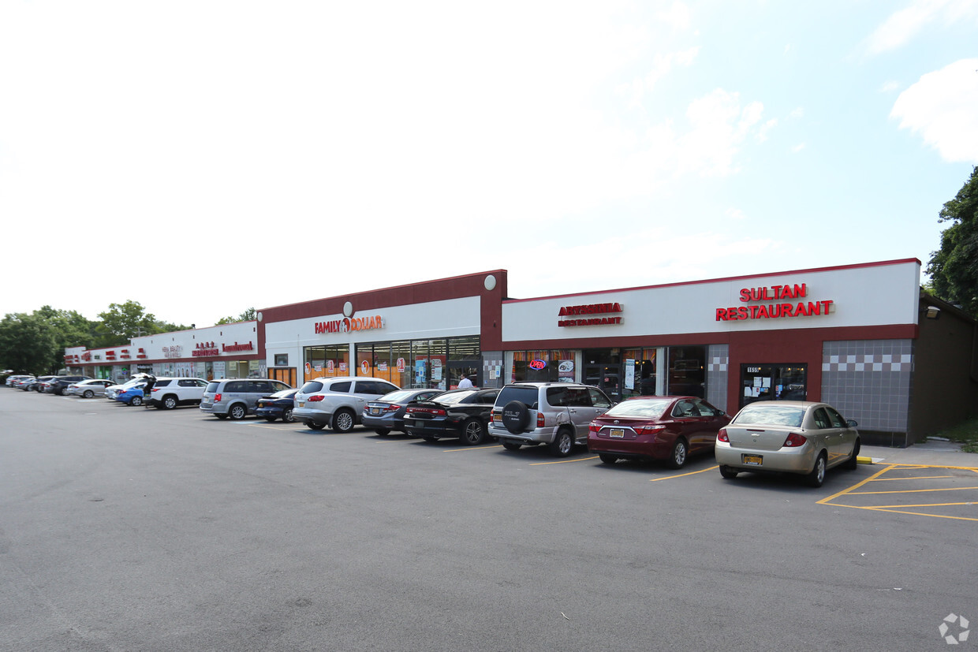

- 1671 Mt Hope Avenue 3857 sf
- Approximatel 32,000 traffic count
- Co-Tenants include: Family Dollar, Country Sweet, Sultans’, SEA Restaurant, Nails, Laundromat, grocery store etc
- 5 minute drive to the University of Rochester/Strong Hospital/Expressway 390
- Within 10 minutes to business district of downtown Rochester/Highland Hospital/Monroe Community College/Veterans Administration etc
- Surrounded by well established residential and office community
- Professionally well maintained shopping Center
- 3 driveway access to shopping center with good unloading in the back
- Back building is medical office and across the street is MAVIS/Taco Bell/St Ann’s Church/Beauty Salons/Bicycle Store

Please let me know if you are interested in touring this location this week or next. Nancy Gastel Realty Advisors (770) 578-1067

