


6 Farm Road, Street
Somerset BA16 0BJ

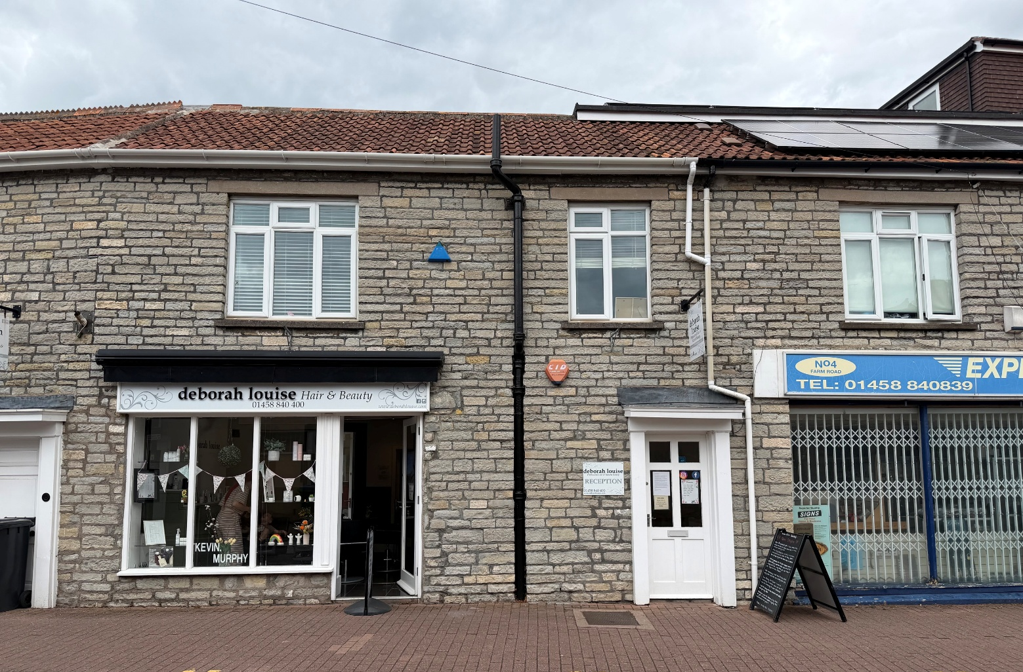

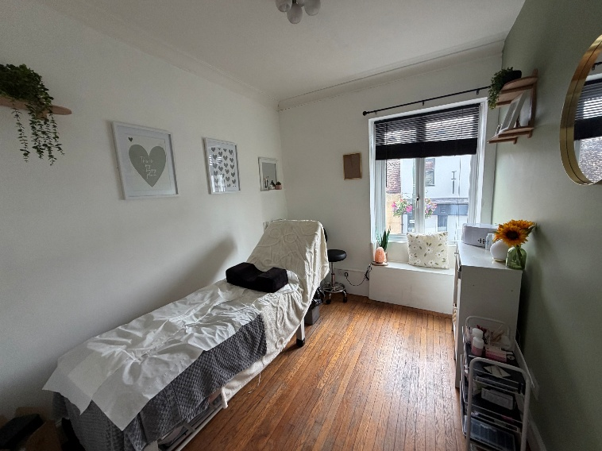
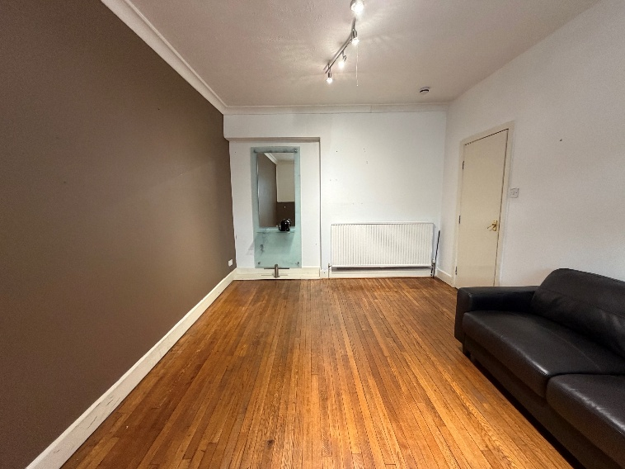
To Let - £13,200 per annum, excl.
A versatile Use Class E commercial property last occupied as a hair dressing salon and beautician’s well suited for similar continued use or wider retail, office or professional users. Situated within the centre of Street nearby Clarks Village.

Location - W3W ///asterisk.protest.maybe

Situated in a prominent central position off Farm Road, Street an excellent through affair connecting the High Street, Clarks Village and car parking. Well suited for a variety High Street and office based uses.

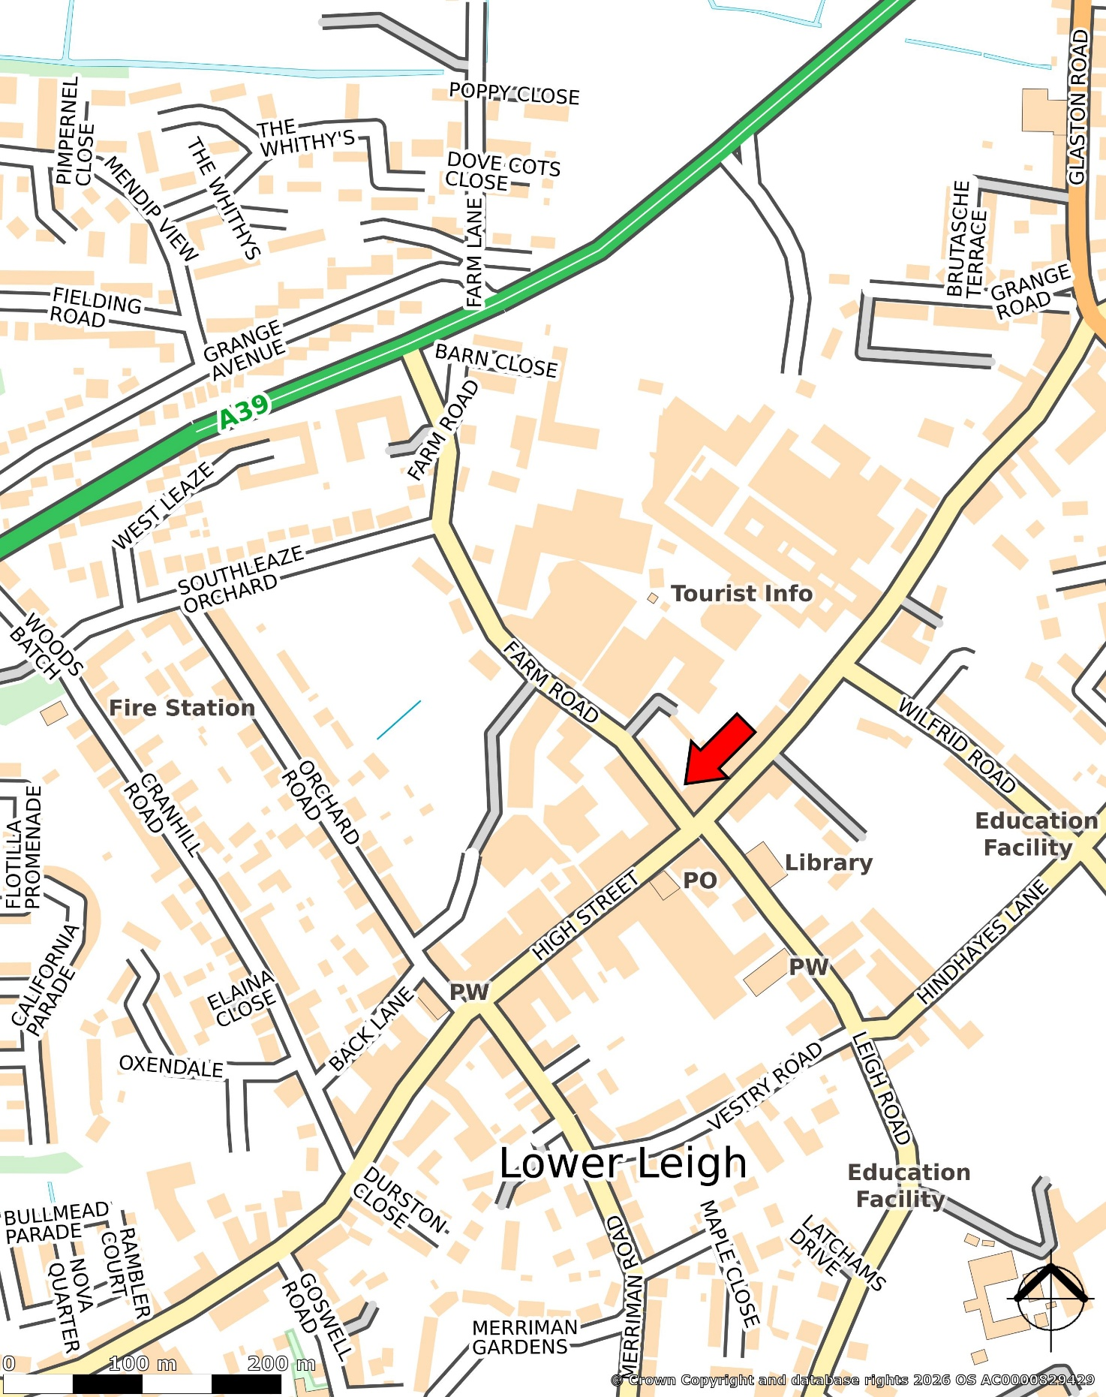

Description
Mid-terrace Class Use E building (Commercial, Business & Service uses) situated within the centre of Street off Farm Road, nearby High Street, Clarks Village and public car parking.

The accommodation comprises as follows: Reception (9.48sqm) stairs to first floor. Step up to Hall (1.09sqm) and Gents WC (1.89sqm) Ladies WC (1.63sqm). There is both an internal and separate external entrance into the Retail Area /Former Salon (23.79sqm), traditional frontage with further additional doorway currently blocked up, max width of 6.2m (retail space only). Kitchen (6.53sqm). (40.80sqm)

First floor Corridor (11.23sqm). Office/Treatment Room 1 (6.47sqm with 0.79sqm limited use over stairs). Storeroom (2.74sqm). Office/T2 (6.06sqm). Office/T3 with external stair access (14.43sqm). Office/T4 (9.98sqm). Office/T5 (7.9sqm). Office/T6 (15.63sqm). Office/T7 (12.53sqm).

Net Internal Area: 128.56sqm / 1,384sqft

No external areas within the demise.

Business Rates
Rateable Value - £9,200 (2026 List). Not rates payable. Small business rate relief may apply. For confirmation on the precise rates payable, please rely on your own enquiries of the local billing authority. Area on the VOA 129.79sqm.

Services and Fixtures & Fittings
The property benefits from connection to mains water, electricity and drainage. Combi boiler hot water and central heating.

No tests have been carried out on any appliances or services at the premises and neither the vendors nor their agents give any warranty as to their condition. Prospective occupiers should make their own investigations. All fixtures, fittings and trading equipment are specifically excluded unless mentioned in these particulars.

Lease Terms
Rental proposals are invited on broadly the following basis:
- Available on a new lease
- FR&I basis
- Rent Review every 3rd anniversary
- Lease to be excluded from the provisions of the Landlord & Tenant Act 1954 Sections 24-28 inclusive (i.e. no automatic right to renew at lease expiry)
- Tenant to contribute £500 + VAT towards Landlord’s proper and reasonable legal costs
- Deposit subject to references/credit checks.

Commercial Lease Code
Prospective tenants should seek professional advice from a qualified property adviser before entering a legally binding contract. Information can be found via: http://www.leasingbusinesspremises.co.uk

Planning
Local authority Somerset Council (former Mendip Area) within the Conservation Area and a designated secondary retail frontage area.

Interested parties should rely on their own enquiries in respect of any planning history, opportunities and existing consented uses and works with the local planning authority.

EPC Rating
EPC Band C/75.
Certificate Number: 5802-9297-3021-4195-5717
Area: 154sqm

VAT
VAT is not payable on the rent.

Enquiries / Viewings
Cooper and Tanner Commercial Department:
Tel. 03450 34 77 58
Email: commercial@cooperandtanner.co.uk


COMMERCIAL DEPARTMENT
Cooper and Tanner
Telephone 03450 347758 / commercial@cooperandtanner.co.uk

Important Notice: These particulars are set out as a general outline only for the guidance of intended purchasers and do not constitute, nor constitute part of, an offer or contract. All descriptions, dimensions, reference to condition and necessary permissions for use and occupation, warranties and other details are given without responsibility and any intending purchasers should not rely on them as statements or representations of fact but must satisfy themselves by inspection or otherwise as to the correctness of each of them.

