Mt. Hope Plaza Additional Pictures
Call: (770) 578-1067 to tour property

Bank Vault and Kitchenette:

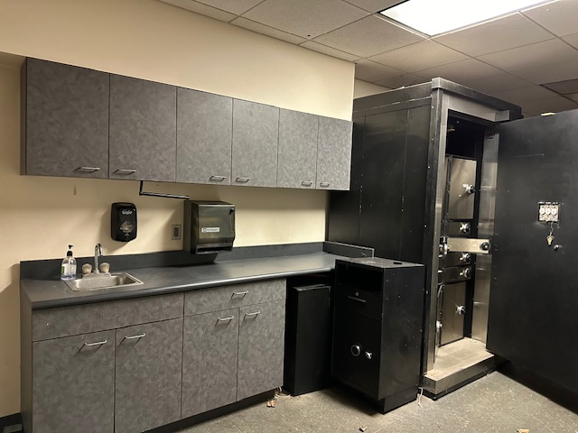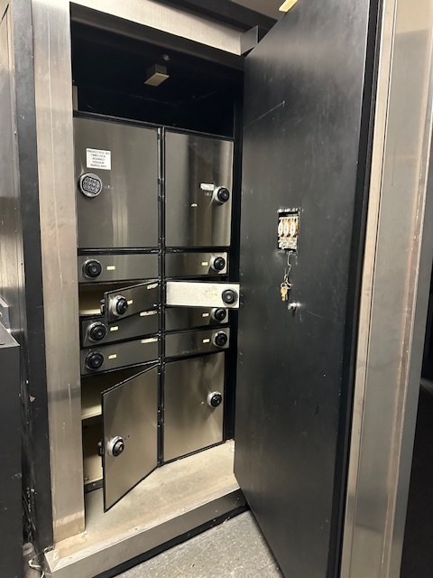

Kiosk for ATM or other possible use with City of Rochester Permit

