Knights Court Retail Center
7746 Highway 6, Suite O
Missouri City, Texas 77459
Approx. 8,547 SF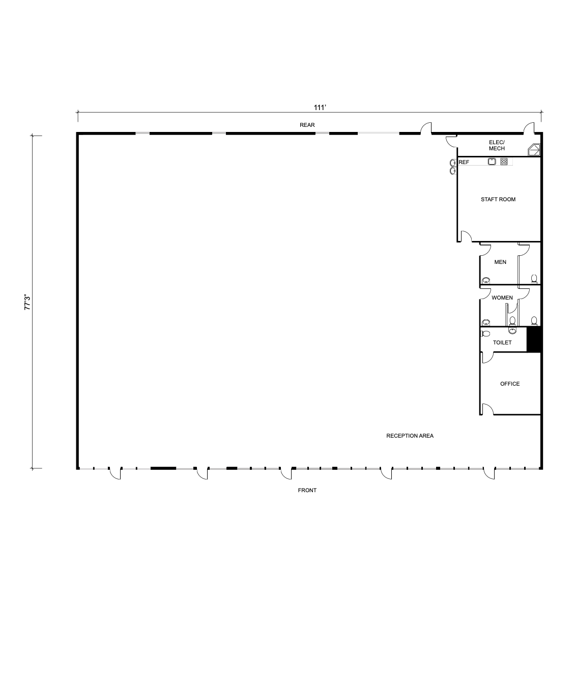
Knights Court Retail Center
7746 Highway 6, Suite M, N & O
Missouri City, Texas 77459
Approx. 14,661 SF

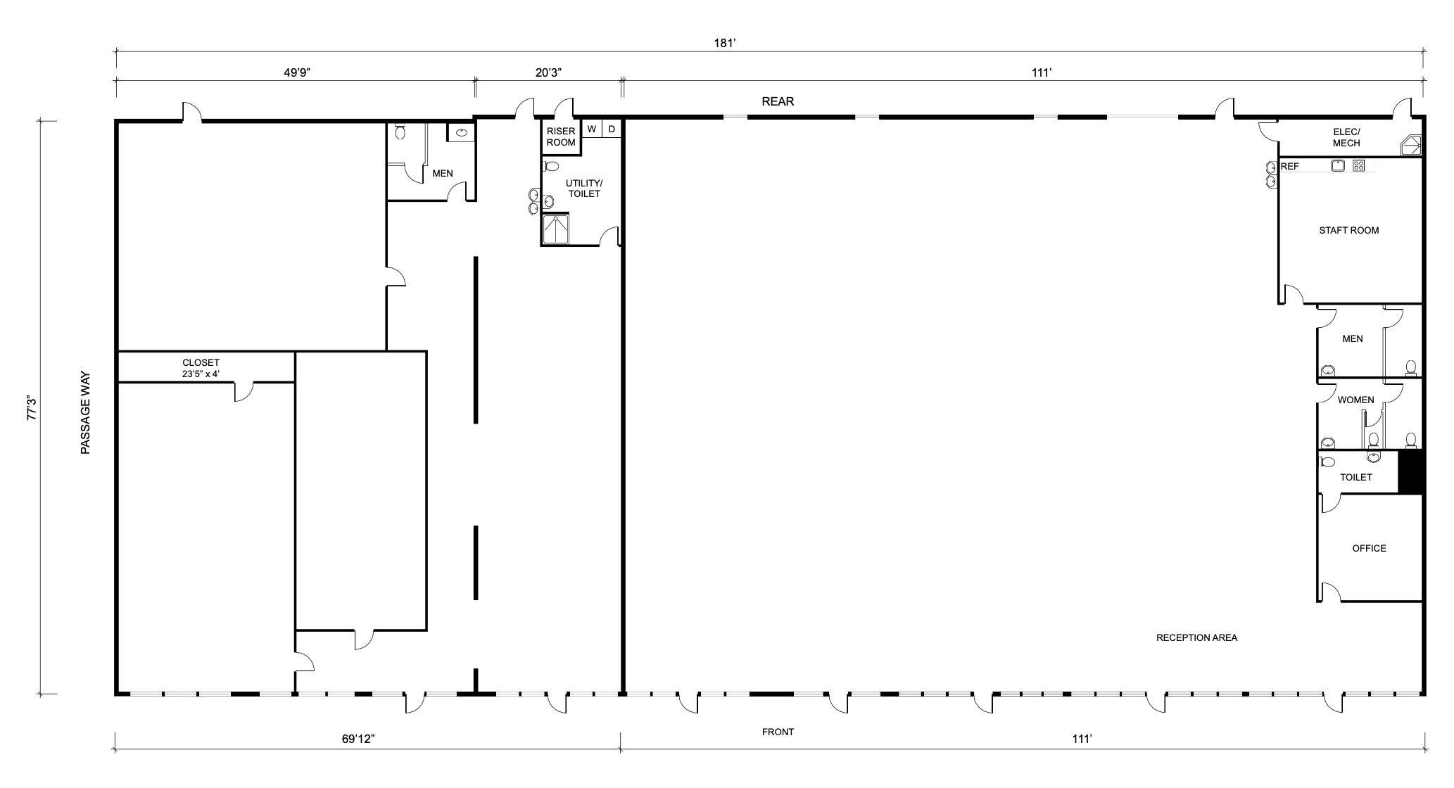

Knights Court Retail Center
7746 Highway 6, Suite M & N
Missouri City, Texas 77459
Approx. 5,590 SF

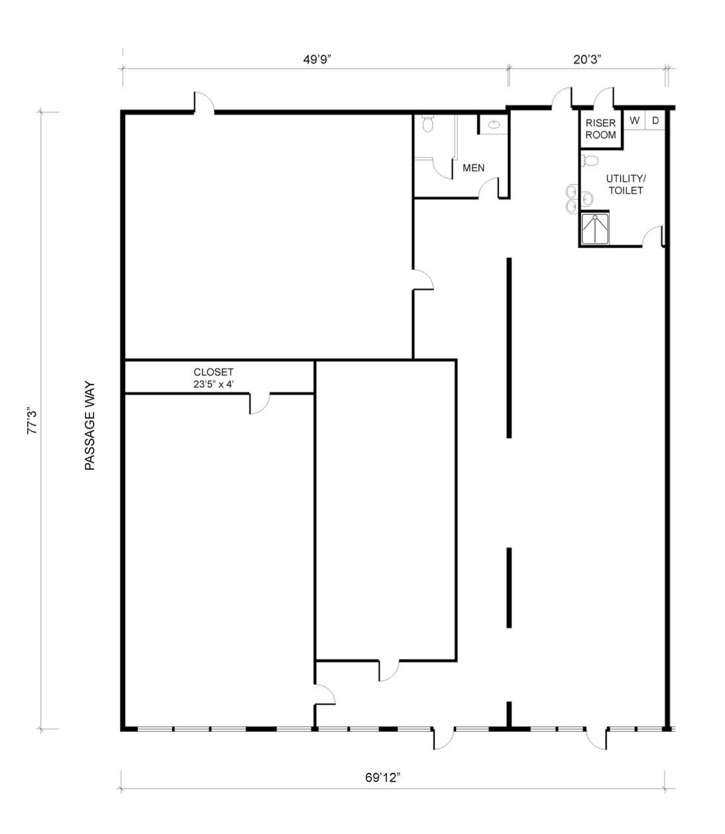
Knights Court Retail Center
7746 Highway 6, Suite M & N
Missouri City, Texas 77459
Approx. 4,050 SF

All measurements are approximate and are not for architectural purposes.

