Humberstone House 81-83 Humberstone Gate, Leicester LE1 1WB
Wasim – 07778964775
vaseeullah02@gmail.com
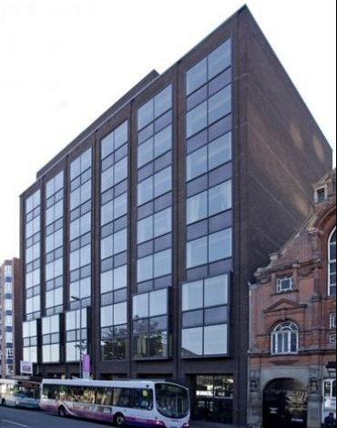
Available Space | Approx size (sq ft) | Desk Recommendation | Price Per Month ex VAT
3rd floor – Suite 3 | 506 | 10 | £1,054.17
3rd floor – Suite 6 | 280 | 5 | £583.33
3rd floor – Suite 7 | 325 | 6 | £677.08
3rd floor – Suite 8 | 345 | 7 | £718.75
3rd floor – Suite 9 | 423 | 8 | £740.25
3rd floor – Suite 10 | 446 | 9 | £929.17
3rd floor – Suite 11 | 500 | 10 | £1,041.67
4th Floor – Suite 7 | 186 | 3 | £445.00
4th Floor – Open plan | 2507 | 50 | £5,222.92
5th Floor – Suite 2 | 125 | 2 | £300.00
5th Floor – Suite 4 | 125 | 2 | £300.00
5th Floor – Suite 5 | 125 | 2 | £300.00
5th Floor – Suite 10 | 650 | 13 | £1,354.17
5th Floor – Suite 11 | 375 | 7 | £781.25
5th Floor – Suite 12A | 375 | 7 | £781.25
7th F-Front -1 | 1,100sf | 18+ | £2,291.67
7th F-Front -2 | 589sf | 8-10 | £1,227.08
7th F-Rear | 2,060 | 30+ | £4,291.67

Description: Humberstone House can offer a range of small suites from 150 sqft up to large open plan space. We offer flexibility for those looking for short term space with inclusive rents, as well as longer term agreements for those that require long term security.

Transport: Being in the heart of the city Humberstone House benefits from excellent transport links. Leicester Railway Station is a 12 minute walk away or a 5-10 min bus journey. Most local busses stop outside the building or close by.

What does the above price include?
- Rent
- Electricity (when a floor is half floor is taken, the meter becomes the tenants / pro rata share of the consumption for half floor)
- Heating
- Service & Maintenance Charges (if a floor is taken, the demise becomes the tenants responsibility)
- Communal cleaning

Additional Costs
- Business rates are not included although many offices should qualify for 100% rates relief but please rely on your own enquiries

