OFFICE / MEDICAL SPACE FOR LEASE
At $2.75 per Sq. Ft. Gross
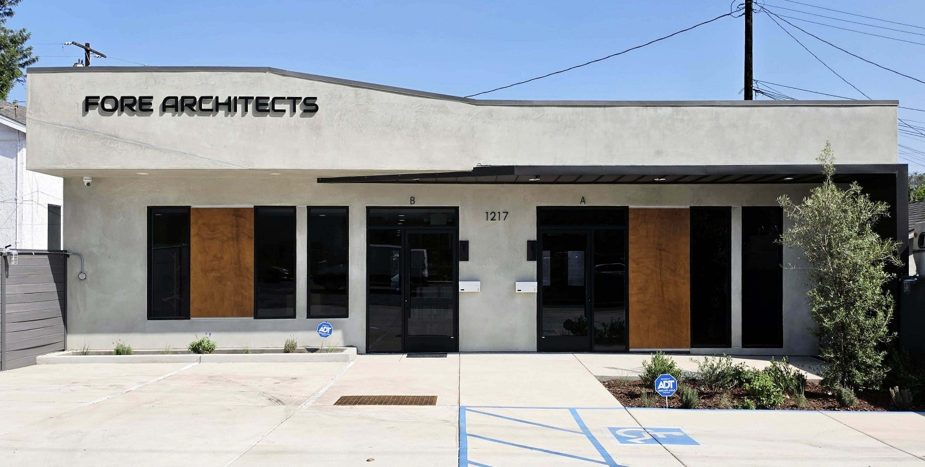

1217 TORRANCE BOULEVARD
TORRANCE, CA 90502

.
PROPERTY FEATURES

• 1,350 Square Feet - FLOOR PLAN ON REVERSE
• Off-Street Parking & Rear Parking (8 total)
• One (1) ADA Restroom
• 64,000 Vehicle Traffic Count per Day
• Great Location Minutes From Torrance, Harbor City, Gardena &
Carson
• Close to UCLA Harbor General Hospital
• Open Floor Plan – Build to Specific Need
Five Minutes from 110 or 405 Freeway

CONTACT
Sojka-Nikkel Commercial Realty Group, Inc.
Jessica Sojka
O (310) 534-8000
C (310) 344-5207

