
FOR LEASE




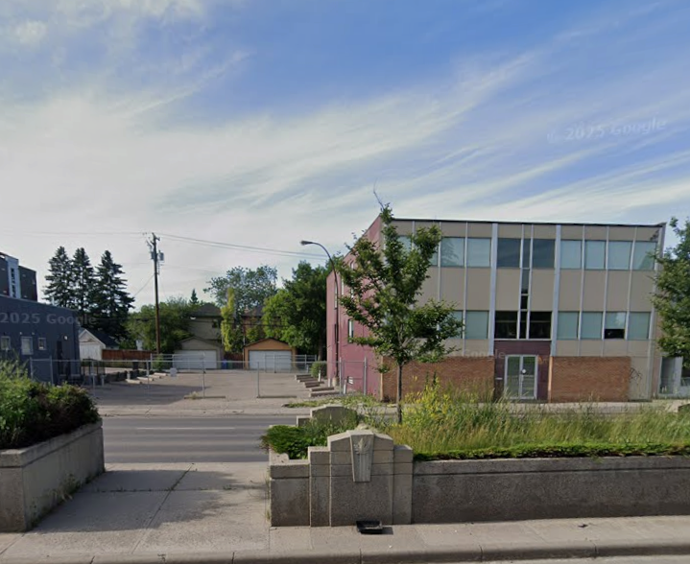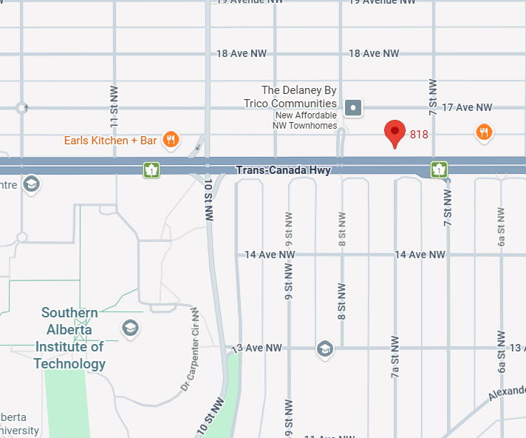
Exceptional Location

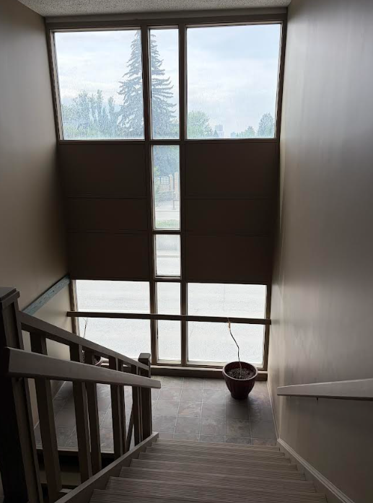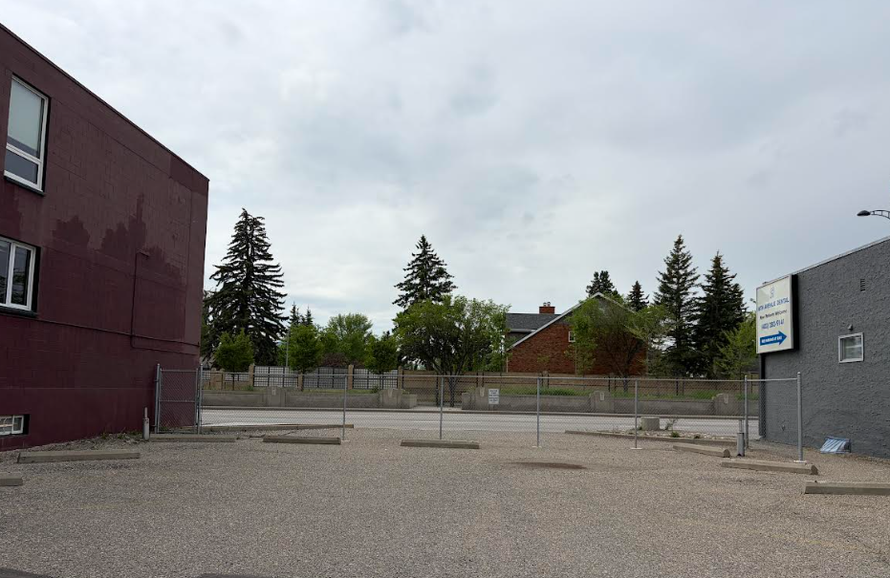

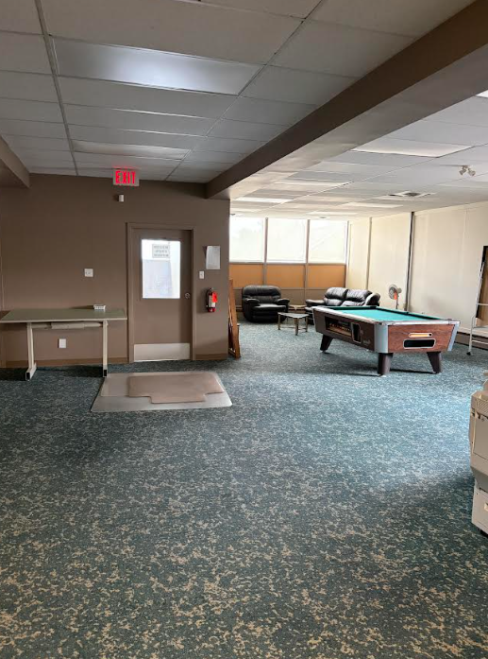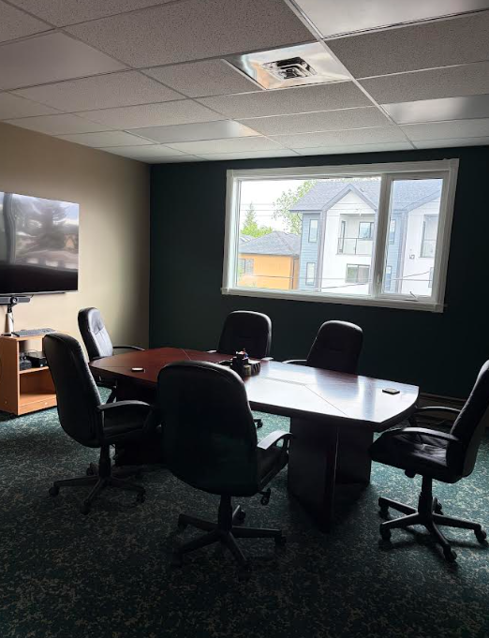

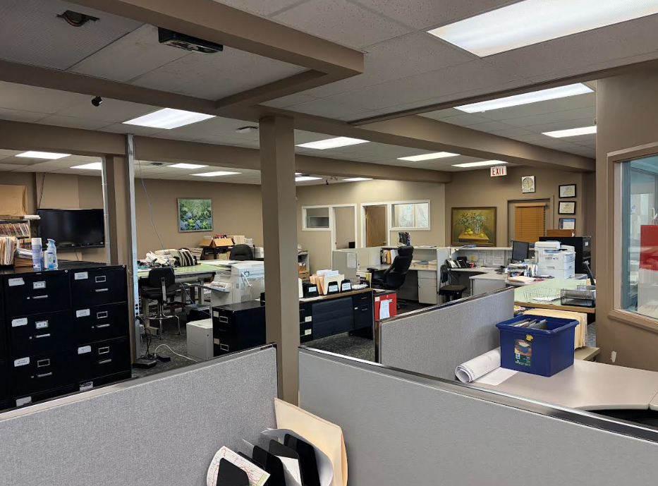

Market Rent
- Prime Location on 16th Ave. NW
- 35,000 to 46,000 vehicles pass per day
- Up to 5,000 square feet available.
- 3 levels with private washrooms and kitchens on all floors
- Tenant Improvement negotiable
- Daycare opportunity with private outdoor space
- Private Parking lot
- Main floor Retail /Office/ Medical use.
- CCOR 1 Zoning
- Air Conditioned Building
- $12.50/sqf ops cost
Danny Quon
403-918-3581
www.equium.ca
818 16th Ave. NW
Prime Location / Daycare / Retail / Medical / Private Parking Lot

